Week 6: Product Review and Rating Management System Create Review and Rating Tables
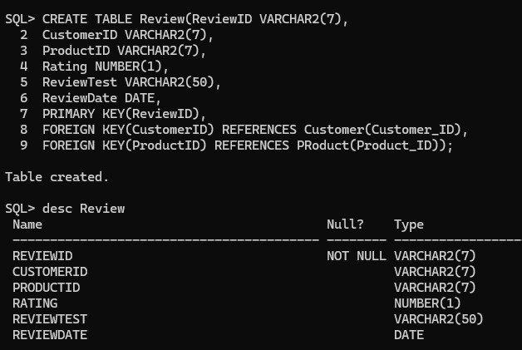

Store Customer Feedback and Ratings Tasks:
  - Add reviews for purchased products.

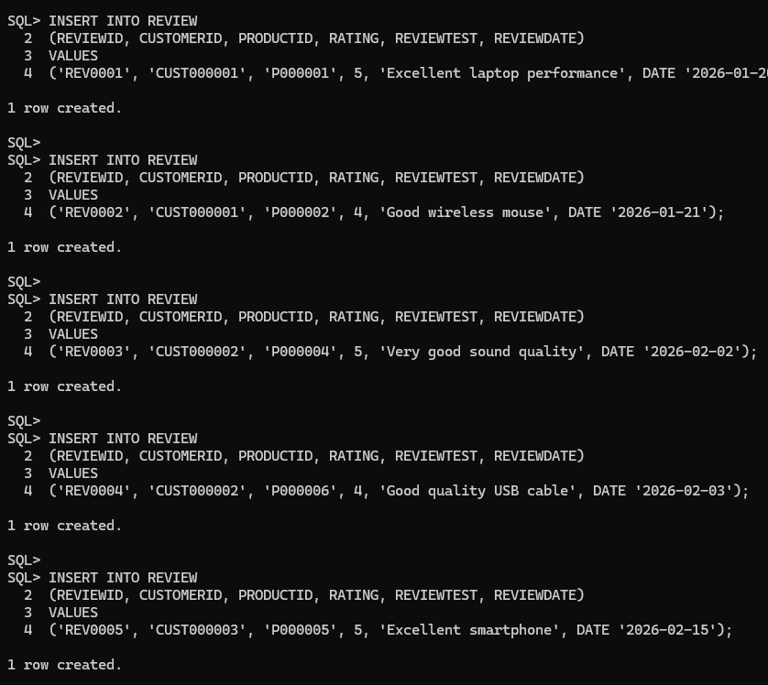

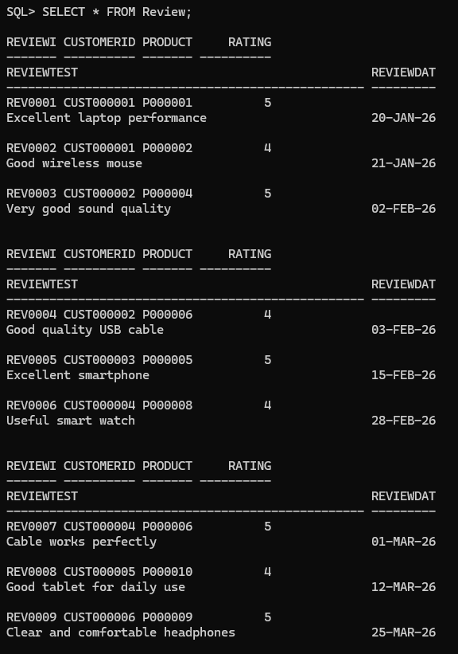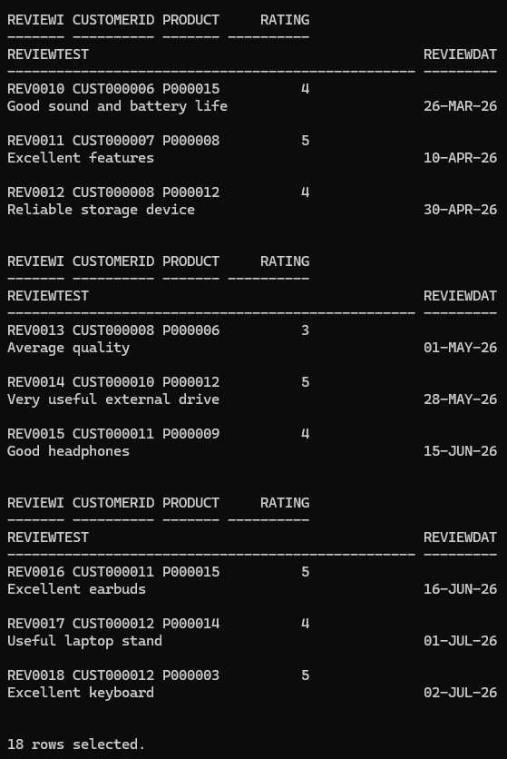
  - Store customer ratings from 1 to 5 stars.

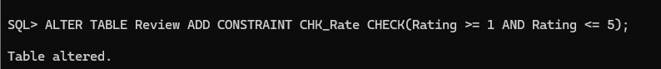
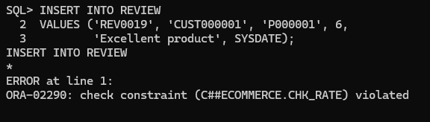
Ensure this by adding Constraint

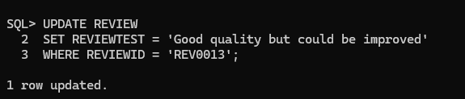
  - Update review comments if required.
  - Remove inappropriate or invalid reviews.
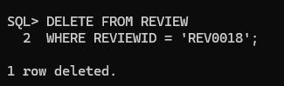

Retrieve Product Review Details Write SQL queries to:
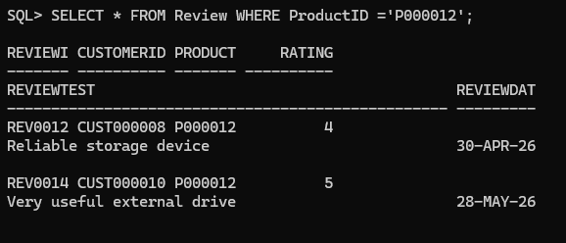
  - Display all reviews for a product.
  - Display customer name with their reviews.

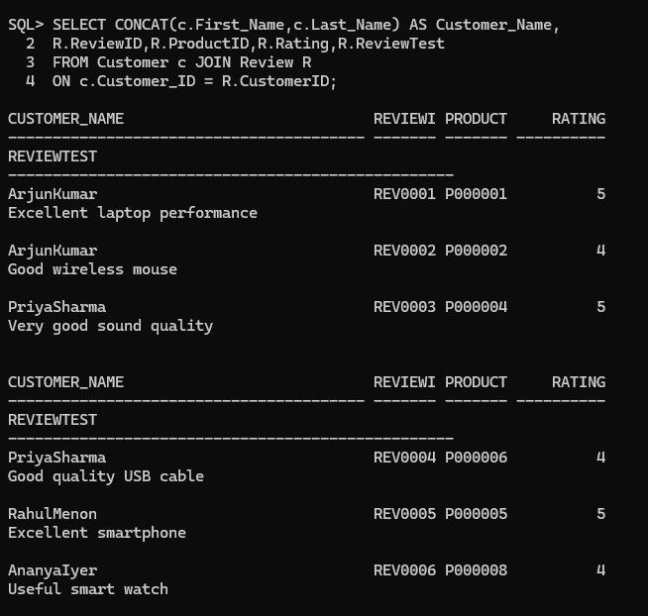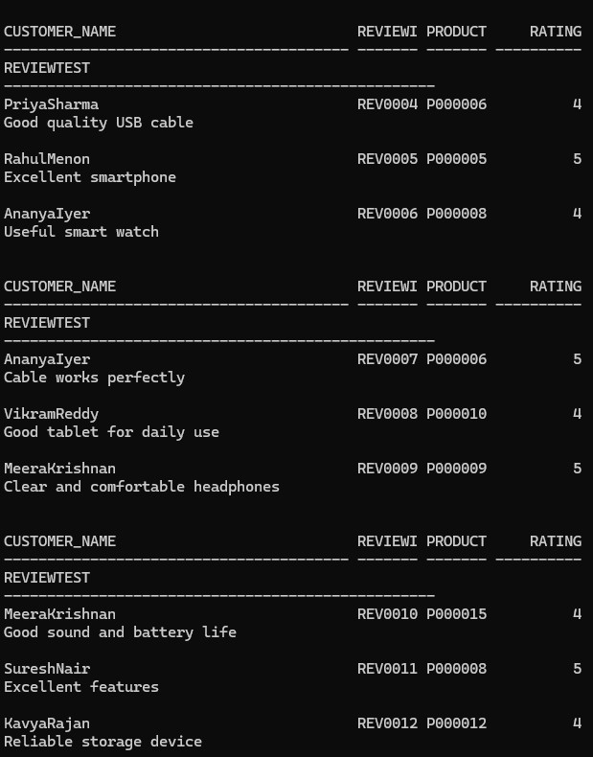

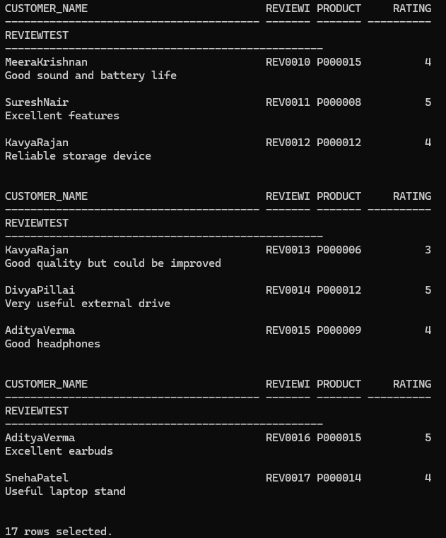
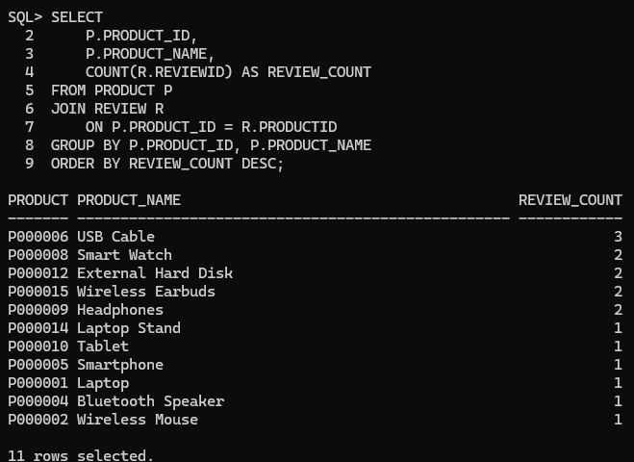
  - Find products having maximum reviews.

  - Display recent customer feedback.

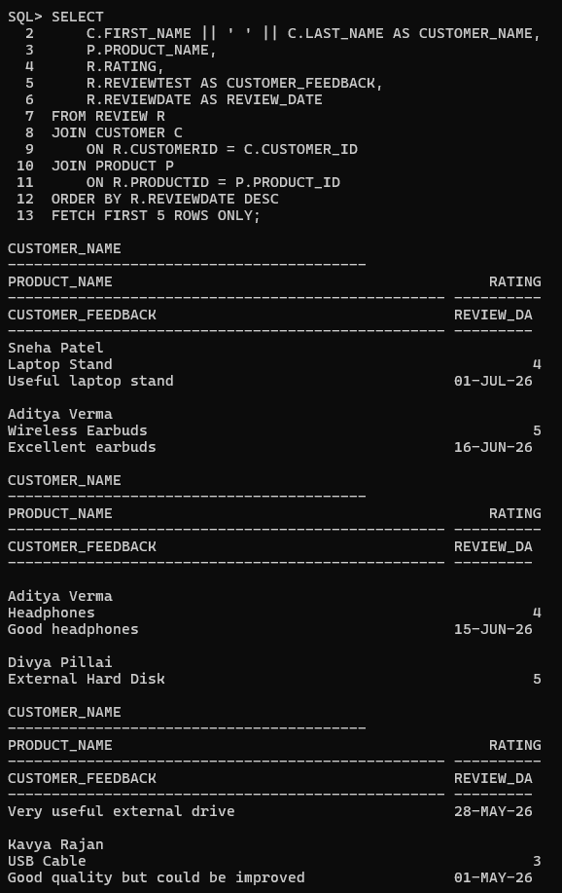
  - Retrieve reviews with ratings above 4.

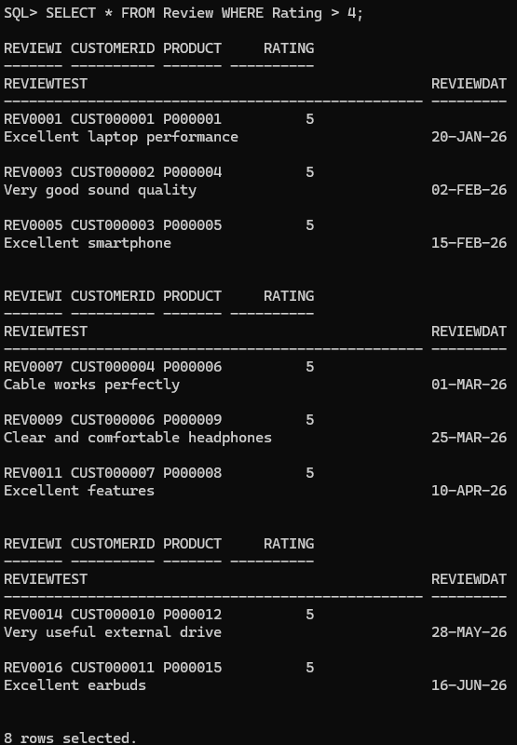

Example Query:
- Calculate Average Product Ratings
Use aggregate functions to analyze ratings.

Tasks:
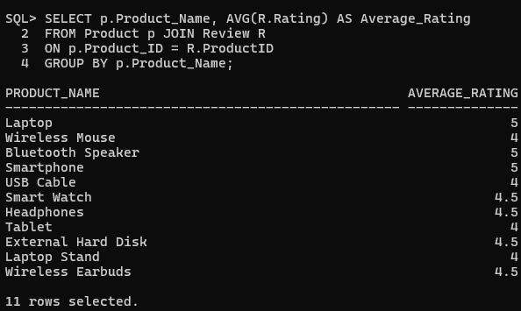
  - Calculate average rating for each product.
  - Count the number of reviews per product.

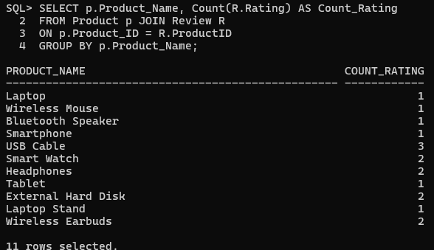
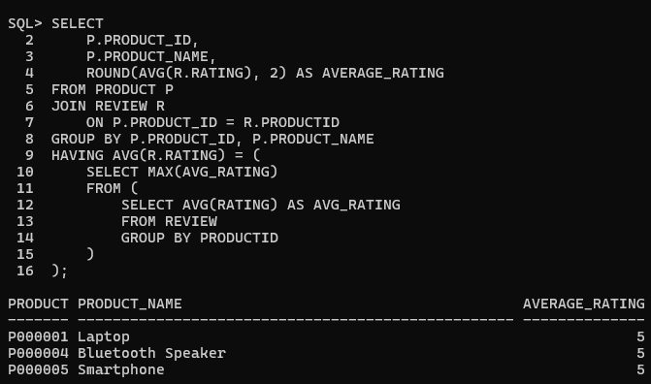
  - Find highest-rated products.
  - Identify products with average rating above 4.
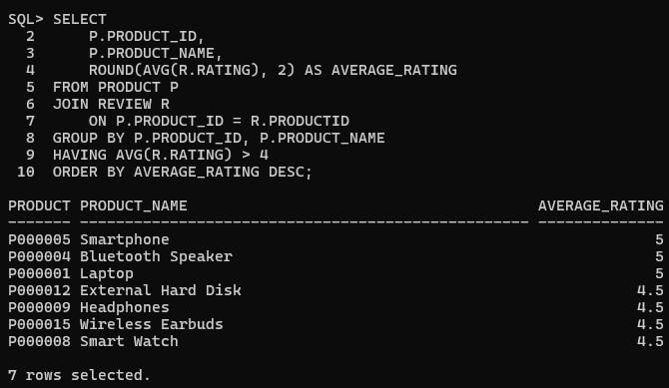
- Identify Highly Rated Products Generate product rating reports. Report 1: Product Rating Analysis Display:
- Product name
- Number of reviews
- Average rating

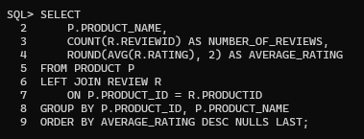
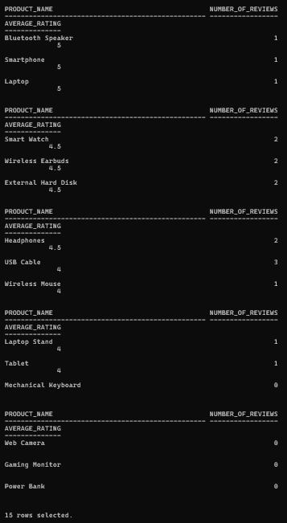

Report 2: Customer Feedback Analysis
Find:
- Most reviewed products
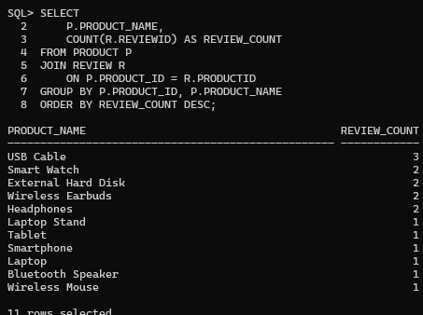
- Highly rated products

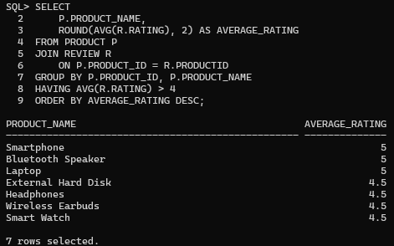
- Products requiring improvement
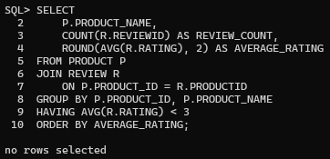

Report 3: Rating Distribution
- Number of 5-star ratings
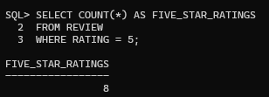
- Number of 4-star ratings
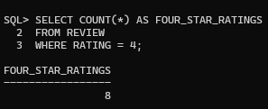
- Number of low-rated products
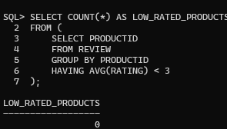
- Complete Rating


